Q0)

Given the following state for the Banker’s Algorithm. Suppose we have 3 resources (R1-3) and 3 processes (P1-3).

R1 = Scanner

R2 = Printer

R3 = CD

Given available vector R1=2, R2 = 1, R3 = 2 Then we have the following situation:

• Snapshot at time T0:

|  |  |  |  |  |  |  |
| --- | --- | --- | --- | --- | --- | --- |
|  | Current Allocation | | | Max Allocation | | |
|  | R1 | R2 | R3 | R1 | R2 | R3 |
| P1  P2  P3 | 0  1  3 | 2  2  0 | 0  1  3 | 6  3  5 | 5  2  2 | 1  2  3 |

a) Calculate the original resources

**b)** Calculate the Need matrix

**c)** Is the system in a safe state? If so, show one sequence of processes which allows the system to complete. If not, explain why. **Show your computation step-by-step.**

d) Process P1 request (1,1,3). Should this request be granted? Why or why not? Show your computation step by step

**Q1**) Given the following state for the Banker’s Algorithm. Suppose we have 3 resources (R1-3) and 3 processes (P1-3).

Maximum resources R1=4, R2=5, R3=6. Then we have the following situation:

• Snapshot at time T0:

|  |  |  |  |  |  |  |
| --- | --- | --- | --- | --- | --- | --- |
|  | Current Allocation | | | Request | | |
|  | R1 | R2 | R3 | R1 | R2 | R3 |
| P1  P2  P3 | 1  2  0 | 1  1  1 | 3  0  1 | 0  1  0 | 4  1  1 | 3  1  0 |

**a)** Calculate the available vector.

**b)** Calculate the Need matrix.

**c)** Is the system in a safe state? If so, show one sequence of processes which allows the system to complete. If not, explain why. **Show your computation step-by-step.**

**d)** P1 need 2 more R2. Should this request be granted? Why or why not? Show your computation step by step

**Q2)** A system has three processes (P1, P2, P3) and three reusable resources (R1, R2, R3). There is one instance of R1, two instances of R2 and three instances of R3. P1 holds an R1 and an R3 and is requesting an R2. P2 holds an R3 and is requesting an R1 and an R2. P3 holds two R2 and an R3 and is requesting an R1.

**a)** Draw the resource allocation graph for this situation.

**b)** Write all the cycle(s) in the graph.

**c)** Does a deadlock exist? Why?

**Q3)**

**A system has four processes and five allocatable resources. The current allocation and maximum needs are as follows:**

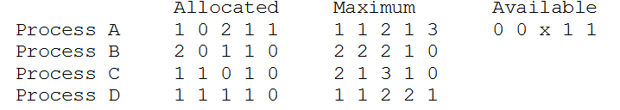

**What is the smallest value of *x* for which this is a safe state?**

**1**